QUALITY POLICY

OFFICINA TOGNI SRL considers Quality, meant as a management system of its business processes, the first factor for the achievement of the Company objectives and for the satisfaction of all internal and external operators with whom the company relates, fundamental for continuous improvement.

The scope of the Quality System is:
Precision machining and manufacturing of mechanical components according to customer design.

Objectives and commitments:
- Understand the internal and external context (economic, social, regulatory, etc.) in which the Company operates, in order to identify the needs and expectations of the interested parties and constantly seek their satisfaction.
- Identify in a clear and complete way the requirements of the Customers by understanding their needs and creating the conditions for their full satisfaction.
- Promote the competence, awareness and involvement of all operators by communicating the objectives and involving people on their achievement.
- Ensure the availability of the necessary resources for the Quality Management System.
- Continuously seek solutions, processes, appropriate and efficient operating methods that allow us to be technologically and organizationally advanced in all company activities having an influence on Quality, preventing the emergence of non-conformities.
- Give opportunities and stimulation to each collaborator through training, motivation and involvement, to contribute to the constant improvement of the Quality System; provide support to other relevant management roles to demonstrate their leadership, as it applies to the related areas of responsibility.
- Operate in full compliance with the contractual conditions, as well as current legislation and regulations, with particular attention to the aspects related to safety in the workplace and the environment;
- Define clear, concrete and measurable objectives by seeking the constant improvement of processes, business performance and the ability to meet the expectations of all stakeholders.
- Maintain cost levels that involve sales prices that, although competitive, allow a profitability that favors the experimentation of innovative solutions.
- Promote the process approach and the use of the risk-based approach.

To achieve the objectives described, the Management undertakes to:
- Provide guidelines and monitor the constant development, maintenance and improvement of the Quality Management System.
- Ensure compliance with the obligations according to the community directives governing our business sector
- Effectively communicate the objectives to all internal and external interlocutors of the Company.

The Quality Policy is made available to all interested parties. The Management of OFFICINA TOGNI promotes alignment with the daily operations of all, so that lasting success may be pursued through the implementation of the QMS and of the improvement of products and services.

Paderno Dugnano -Milan . Italy
05th October 2020
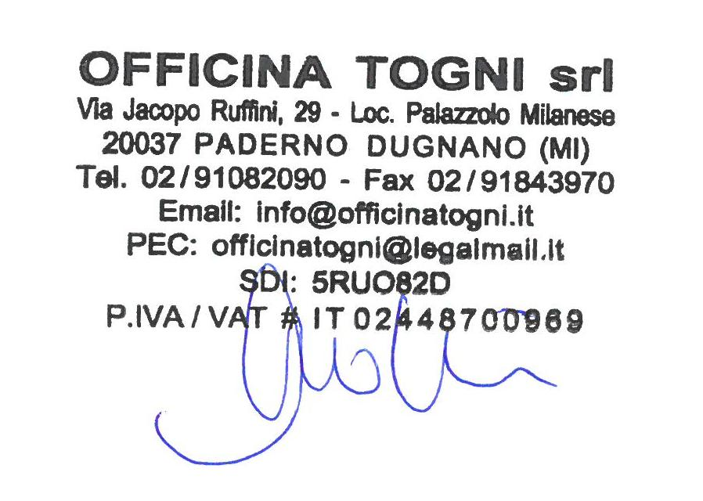
Manuela Togni
General Manager

