About us
LTLAB UAB is an EMS company from Lithuania with 17 years of experience, providing professional electronics assembly services. We perform SMT, THT, prototype and/or mass production assembly, testing, and engineering support for production documentation. We operate under ISO 9001, 14001, and 45001 management systems and comply with electronics assembly and repair standards IPC-7711/7721, IPC-A-610 Class 2 and 3.
We ensure flexibility in production processes, fast communication with specialists, and traceability of components. We are a reliable manufacturing partner from project definition, component sourcing, prototype assembly, mass production, testing, packaging, and delivery to the client.

Services
- Contract manufacturing of prototypes, small, medium, and large batches
- Engineering consultations for optimal price-quality ratio
- Component sourcing, solder paste stencil production, SMD/TH assembly, testing, depaneling, packaging, logistics
- Product assembly, component authenticity verification
- X-Ray system (for authenticity doubts)
- Surface-mount (SMD) component assembly using SMT technology, soldering in convection ovens in N₂ environment
- Manual/automatic selective soldering of through-hole (THT) components using lead-free technology in N2 environment
- PCB assembly process testing – solder paste application control with 3D SPI, component placement control with 3D AOI, solder joint inspection with 2D/3D X-Ray computed tomography
- PCBA cleaning system with sterilization function for flux, dust, and other contaminants

Our advantages
- Fast quotation delivery
- Engineering consultations to ensure best service pricing
- Component price evaluation and sourcing possibilities (2–5 business days)
- Flexibility – prototypes and small batches from 1 unit, production within 2–5 business days
- Specialized Hi-Mix SMT line for prototypes and small batches
- Two precision, fully automatic selective soldering machines for THT using lead-free technology and N2 soldering zone
- Two high-speed SMT lines – up to 2 million components per day
- Predictable lead time for larger batch orders – up to 15 business days
- Fully insured company operations
- Strong production capacity and quality standards

Production Capabilities and Quality Standards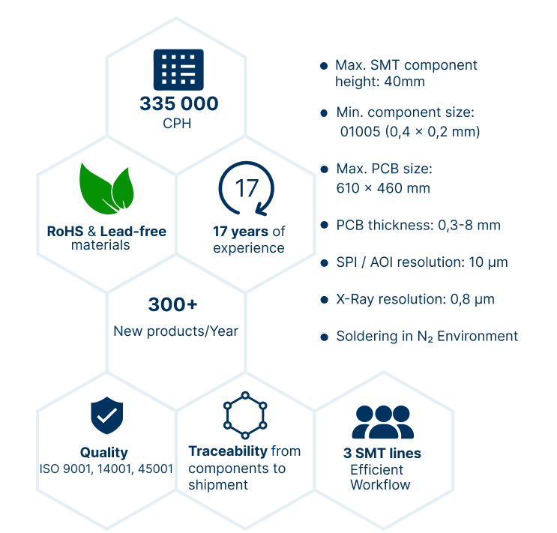

Contact information
 | Kauno st. 34, 03202 Vilnius, Lithuania
 | Lukas Kuzmarskis | Sales Manager
 | +370 686 68440; +370 650 67889
 | sales@ltlab.eu; production@ltlab.eu
 | www.ltlab.eu
 | linkedin.com/company/ltlab

